CHEMICAL ENGINEERING TRANSACTIONS  VOL. 76, 2019 | A publication of
The Italian Association
of Chemical Engineering
Online at www.cetjournal.it
Guest Editors: Sauro Pierucci, Jiří Jaromír Klemeš, Laura Piazza
Copyright © 2019, AIDIC Servizi S.r.l.
ISBN 978-88-95608-73-0; ISSN 2283-9216

Fuel Spill after Ship Collision: Accident Scenario Modelling for Emergency Response
Stefania Magri’ª*, Mauro Quagliatiª, Patrizia De Gaetanoª, Tomaso Vairo^{ab}, Bruno Fabiano^{b}
ªARPAL – UTCR, via Bombrini 8 – 16149 Genoa, Italy
^{b}DICCA Civil, Chemical and Environmental Eng. Dept. – University of Genoa, via Opera Pia 15 – 16145 Genoa, Italy
* stefania.magri@arpal.gov.it

Mitigation associated with oil spill events in sea environment depends largely on the design and implementation of adequate contingency plans, which should incorporate the simulation of the spill dispersion patterns and the characterization of marine and coastal areas that could be affected. This paper is focused on the development of an actual emergency response plan following a major sea accident verified in the Liguria Sea and causing a fuel spill of about 600 m³. The theoretical approach relies on a model developed on a Lagrangian scheme, running decoupled from hydrodynamics, for predicting fate of substance of hydrocarbon origin and covering both the transport and the weathering. Simulations were performed on the basis of daily updated meteo-hydrodynamics forecast produced by the operational circulation model of the Liguria Sea (MIKE 3 HD), reports of sightings of material from the Coast Guard and images of the spill captured by Copernicus Sentinel-1 satellites. The reliability of the modelling was assessed via analysis based on real oil trajectories. .A remarkable agreement was verified between calculated oil forecast, satellite images and actual empirical sightings of material, confirming the effectiveness of the combined modelling approach in oil spill risk assessment and in setting-up emergency planning.
  - Introduction
A number of international regulations, safety and design standards were developed over the years to prevent groundings, collisions, and steering or propulsion failures with the focus of mitigating accidental spills over the sea. Should an accident occur, planning of spill response measures and their effectiveness are strictly dependent on the oil spill trajectory and fate prediction and still represent an up-to-date research area. Mitigation for the given context is mainly based on preparedness to respond and should include safety operations, identification of site-specific hazards and risks and protection needs and available resources. An effective contingency plan to mitigate spill risk should incorporate the source term identification, the modelling of the dispersion patterns and the characterization of sensitive areas potentially affected by the spill (Vairo et al., 2017a). In this regard, following source term identification and quantification, reliable numerical modelling can provide important information to predict and evaluate the hazardous distance and the reaction time scale thus developing an effective contingency plan (Vairo et al., 2017b). In port areas, consequences can derive also from the development of flammable and/or toxic clouds due to hydrocarbons vaporization, so that specific safety measures must be adopted, based on the knowledge of the time-dependent concentration of the hydrocarbon vapours in the cloud along with the three spatial coordinates (Palazzi et al., 2004). The fate and behaviour of oil spill in open sea environment is governed by a series of complex, physical and chemical processes, such as spreading, evaporation, emulsification, dissolution, biodegradation, current transport and sedimentation, highly depending on the properties of the spill, hydrodynamic and environmental conditions. The reader is addressed to the comprehensive reviews on different spill modelling approaches provided by ASCE (1996) and Foreman et al. (2005). The remainder of this paper is as follows: section 2 outlines the system modelling strategy based on a thorough hydrodynamic simulation by a Lagrangian particle approach, section 3 and 4 illustrate the capability of the proposed approach applied to an actual sea accident, comparing results from numerical simulations with experimental evidences, while conclusions are drawn in section 5.
  - Methodology and modelling
The proposed modelling approach is based on the application of an oil spill module decoupled from the hydrodynamics provided by the forecast operational model at Liguria Sea scale, operating at ARPAL. The three-dimensional hydrodynamic circulation model is achieved utilizing MIKE 3 HD approach (Hørsholm, Denmark), which simulates level and stream variations as a function of all the relevant phenomena affecting coastal hydrodynamics and ocean environments: density gradients (temperature/ salinity), effect of the tides, wind effect, heat exchange with the atmosphere and the Coriolis force. The hydrodynamic circulation model relies on data from the Mediterranean-scale circulation (Model MFS Copernicus), combined with weather data from the meteorological model MOLOCH developed at the Meteo Hydrological Functional Centre for Civil Protection (CFMI-PC) in ARPAL. Resolution is based on a numerical finite volume discretization method, on the flow and transport equations in the horizontal dimension, with a non-structured triangular mesh having a variable resolution from offshore and towards the coast (Vairo et al., 2018). The operational chain runs on a daily basis, and provides a 48 h prediction of circulation, sea level, salinity and temperature. The hydrodynamic stream fields provide the basis for the calculation of hydrocarbons transport. The Lagrangian dispersion model describes the oil by two fractions: a light volatile and a heavy non-volatile one, while the chemical transformation of the spilled organic product is considered as a function of the state variables, as results of physical and biological processes.
  - Sea spill scenario
On October 7th, 2018 under calm weather and sea conditions (10-meter wind speed < 2m/s), at 7.00 a.m. ca. two ships collided about 30 km North of Cap Corse and Capraia island, in French waters. There were no casualties, but the collision caused a fuel leak – which has resulted in an oil slick with a major extension of nearly 20 km. The area (shown in Fig. 1) is characterized by a high environmental value, being placed in the international sanctuary for Mediterranean marine mammals, the Pelagos Sanctuary that covers an extension of 87500 km² of the northwestern Mediterranean Sea and 2022 km of coast, extending between southeastern France, Monaco, northwestern Italy and northern Sardinia, and surrounding Corsica and the Tuscan Archipelago. The RAMOGEPOL Agreement relating to marine pollution between France, Monaco and Italy was activated by the French Maritime Prefect for the Mediterranean, and ARPAL was involved to provide support to Liguria Coast Guard. The collision of the two ships caused a breach several metres long in the tanks of the container ship, from where fuel immediately began to leak out. Sentinel-1 is a constellation of two polar-orbiting satellites, under the EC “Copernicus” environmental monitoring program, operating day and night performing C-band synthetic aperture radar imaging, enabling them to acquire imagery regardless of the weather. Since radar measures surface texture, oil slicks show up well – as black smears on a grey background while other dark areas show patterns featuring low reflectivity of the radar signal, for instance very calm waters.

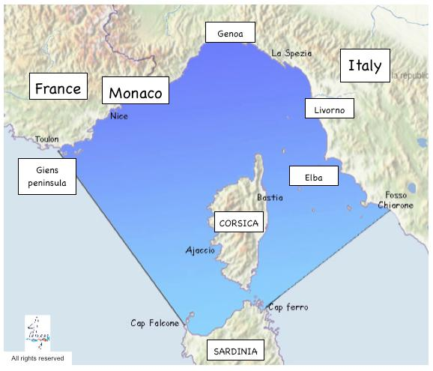

Figure 1: Map of the Pelagos Sea Cetacean Sanctuary (source: www.sanctuaire-pelagos.org).
Figure 2: Oil spill spread captured by Sentinel-1 satellites on 8 October 2018 at 07:28 CEST (05:28 UTC).

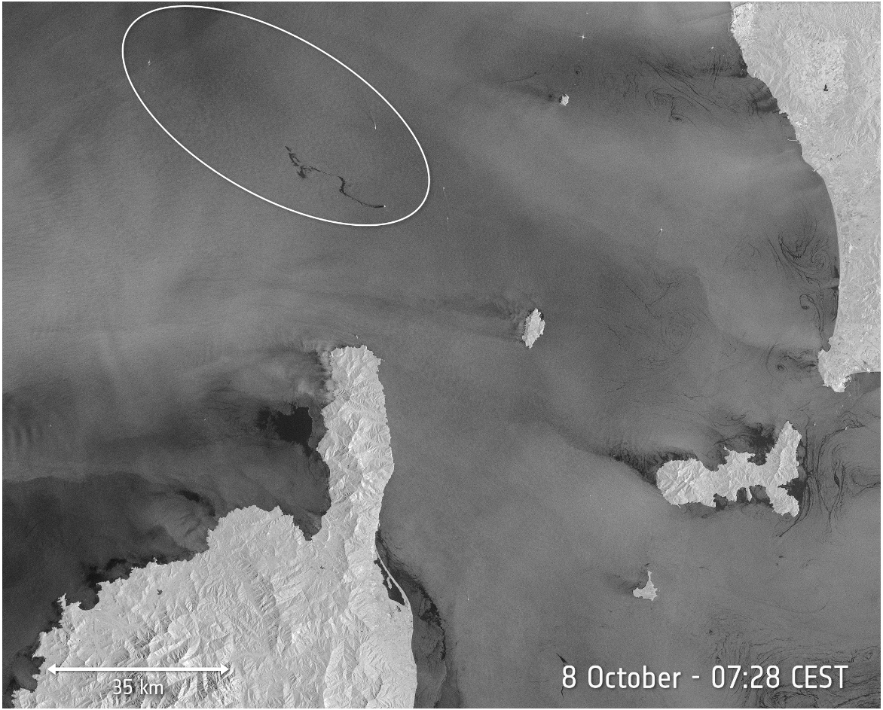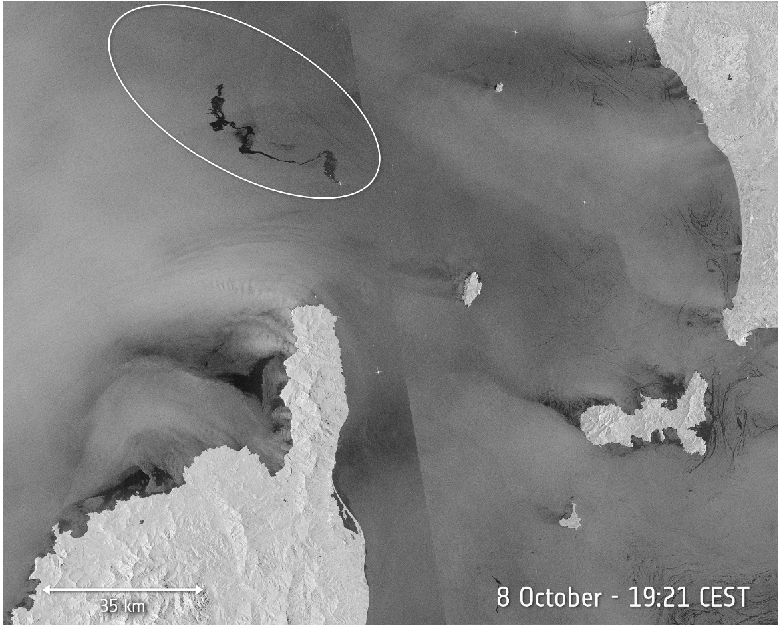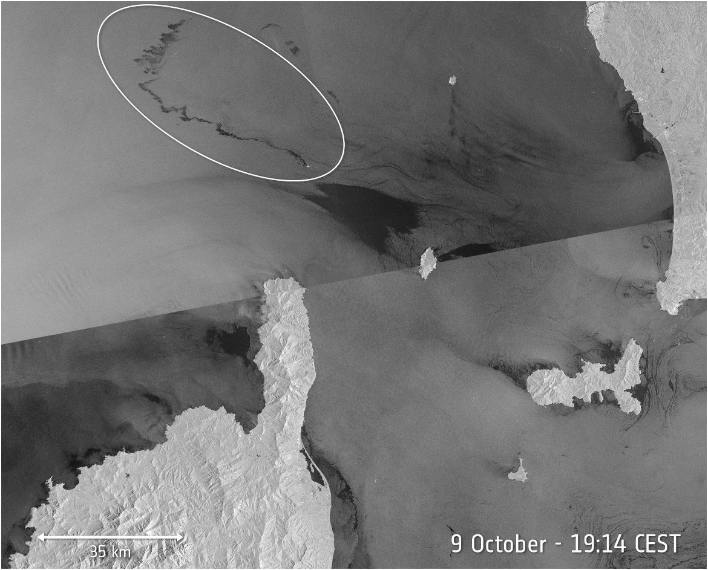
a
b
c
Figure 3 (a,b,c): Oil slick evolution captured by Sentinel-1 satellites, on 8 October 2018 at 07:28 CEST, 8 October 2018 at 19:21 CEST,9 October 2018 at 19:14 CEST.

Sentinel-1 images are used by the European Maritime Safety Agency as part of CleanSeaNet, the European satellite-based oil spill and vessel detection service. On 8th October 2018 at 07:28 CEST (05:28 UTC), the Copernicus Sentinel-1A satellite captured its first images of the oil spill from the collision between the two ships on Sunday 7th October 2018, which can be seen as a dark patch north of the tip of Corsica. Fig. 2 visualizes the pollution extension just after the collision time, covering nearly 20 km. Fig. 3 a,b,c shows the evolution of the oil slick in the subsequent days: by the evening at 19:21 CEST, the slick had lengthened to about 35 km while 24 hours later, on 9th October at 19:14 CEST, the extension reached nearly a length of 60 km.
  - Results and discussion
Numerical simulations started on 7th October, assuming the hypothesis a continuous fuel release scenario following ship collision. The availability of satellite data allowed validating the models of spill evolution, to map the area affected by the pollution used for re-initialization of the slick position for the updated forecast. Aaccording to the currents regime simulated by the hydrodynamic model, Fig. 4 evidences the particles trajectory towards NW after 24 hours. Comparison between the slick forecasted position and Sentinel-1A satellite image in Fig. 4 shows a fairly good agreement, with a prevailing direction of the oil slick again towards NW. Satellite data were used for the model re-initialization of the slick position for the following simulation, based on the meteo-oceanographic forecast produced on October 8th 12:00. Results are shown in Fig. 5, again with a good accordance between the slick forecasted position and Sentinel-1A satellite image. For the following days, only visual observations by aircraft were available and were used to follow the evolution of the hydrocarbon trails (Fig. 6). Until the two ships were separated on 11th October evening, simulations were carried on considering a continuous spill scenario from the ship tank. The dispersed oil slicks remaining after recovery operations headed toward western Liguria at a distance of about 12 miles from the coast and eventually reached the French coastline. (see Fig. 7). In general, the simulated results show that the model is capable of predicting the oil spill behaviour in sea environment. As a main drawback of the approach, it is noteworthy noting that the simulation was unable to catch the final eastward change in the slick direction, highlighting the need of actual observations to assess the forecasts reliability and operate re-initialization for long range planning.
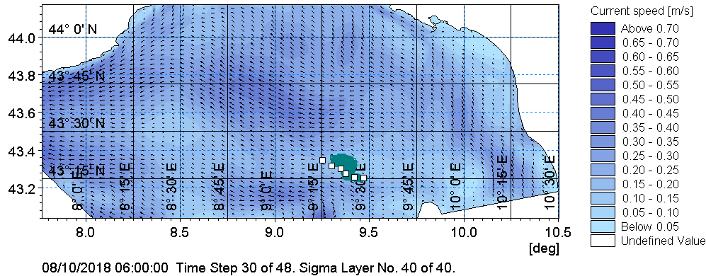

Figure 4. Slick position on 8th October 2018 at 09:00 UTC: comparison between simulated (dark) and experimental data by Sentinel-1 satellites (white dots).
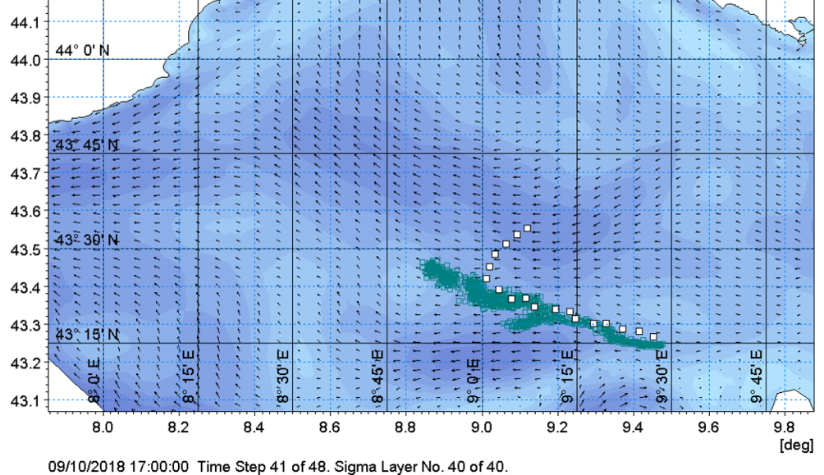
Figure 5. Slick position on 9th October 2018 at 17:00 UTC: comparison between simulated (dark) and experimental data by Sentinel-1 satellites (white dots).

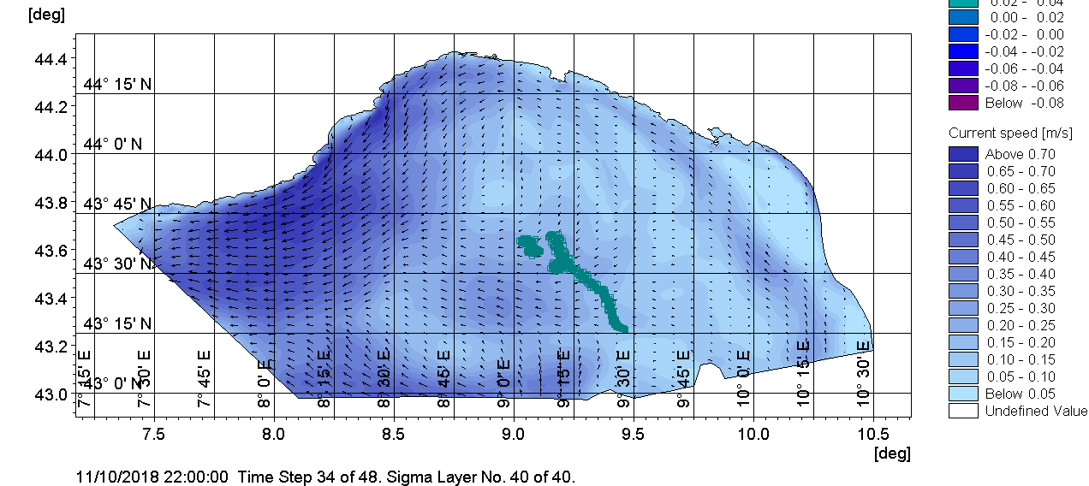
Figure 6. Forecast of the oil slick on 11th October 2018 at 22:00 UTC obtained with initial source position by aircraft observations and a continuous spill scenario from the ship tank.

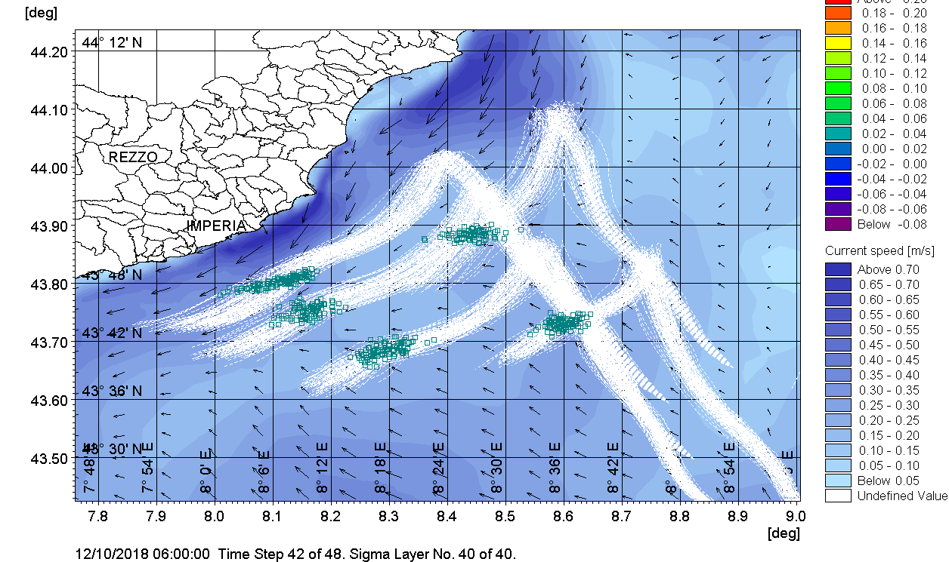

Figure 7. Forecast of the oil slick fate on 12t^{h} October 2018 at 22:00 UTC, obtained with initial source position provided by aircraft visual observations.
  - Conclusions
Owing to the large area potentially affected by spill evolution, environmental remediation efforts can be geographically widespread, time consuming and extremely expensive. The use of modelling to predict oil slick trajectory and fate in sea environment and thus identify the areas at sea and shore potentially affected by the spill can represent an important tool to support the emergency response. This paper described how oil spill modelling was used to support the Coast Guard during the emergency response of the accident, delimiting the marine areas affected by this oil spill and evaluating possible impact on the coast. The success of this approach can be found in its efficacy in detecting the directions along which oil transport is likely to develop. Results evidence the importance of availability of observation data, useful during the emergency phases to assess the forecast reliability and improve the long-range predictions. The availability of empirical data is essential to improve the performance of the computational model in terms of resolution, meteorological forcing and parameterization of physical processes. The described approach can provide a technical basis for setting-up emergency planning, with appropriate response equipment and thus minimizing coastal impact from a spill.
References
ASCE, 1996 State-of-the-art review of modeling transport and fate of oil spills. Task Committee on Modeling of Oil Spills of the Water Resources Engineering Division. J. Hydraul. Eng., 122, 594-609.
ESA (European Space Agency), 2018, Copernicus: Sentinel-1 < https://earth.esa.int/web/eoportal/satellite-missions/c-missions/copernicus-sentinel-1> accessed 10.10.2018.
Foreman M.G.G., Beauchemin L., Cherniawsky J.Y., Peña M.A., Cummins P.F., Sutherland G., 2005. A review of models in support of oil and gas exploration off the north coast of British Columbia. Can. Tech. Rep. Fish. Aquat. Sci., 2612: v + 58p.
George, P., Skjong, R., Vanem, E., 2011. Risk acceptance criterion for tanker oil spill risk reduction measures. Mar. Pollut. Bull. 62, 116–127.
Palazzi E., Currò F., Fabiano B., 2004, Simplified modelling for risk assessment of hydrocarbon spills in port area, Process Safety and Environmental Protection 82, 412-420.
Pelagos, 2018, Pelagos Sanctuary <sanctuaire-pelagos.org> accessed 10.01.2019
Vairo T., Del Giudice T., Quagliati M., Barbucci A., Fabiano B., 2017a, From land- to water-use-planning: A consequence based case-study related to cruise ship risk, Safety Science 97, 120-133.
Vairo T., Magrì S., Quagliati M., Reverberi A.P., Fabiano B., 2017b, An oil pipeline catastrophic failure: accident scenario modelling and emergency response development, Chemical Engineering Transactions 57, 373-378.
Vairo T., Magri S., De Gaetano P., Quagliati M., Fabiano B., 2018, Multicomponent dispersion of hydrocarbons at sea: source term evaluation and hydrodynamic simulation of the spill, Chemical Engineering Transactions 67, 61-66.
WHO, 2007, WHO six-year strategy for the health sector and community capacity development <who.int/hac/techguidance/preparedness/emergency_preparedness_eng.pdf> accessed 10.01.2019.

